Computer Language Coding Concepts

Interface Assignment in a Diagram
The principle of interface assignment is explained in the article Interface Assignment. This article demonstrates the expression of it in a diagram.

About the notation of assignment in general, see the article Assignment in a Diagram.

An assignment is a call to an assignment command, but the expression of an assignment call is given a more basic notation, like this:

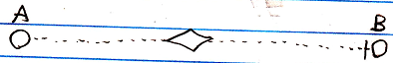

The fact, that the lines are dotted, expresses, that it is an interface assignment. The access mark indicates the direction. The target interface of object reference A is assigned to object reference B.

Command interface assignment works exactly the same. Here’s an example of a command interface assignment:

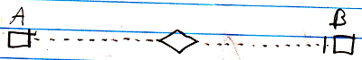

See also: Assignment in a Diagram, Interface Assignment

Author & Copyright: Jan-Joost van Zon Date: July 13, 2008 – July 24, 2008 Location: Oosterhout, The Netherlands Status: Finished

